PAGE DESCRIPTIONS

http://www.thegreenrooms.net
The Green Rooms – Counselling, Psychotherapy, NLP & Life Coaching
SLIDING PICS:
DENTIST
BOY
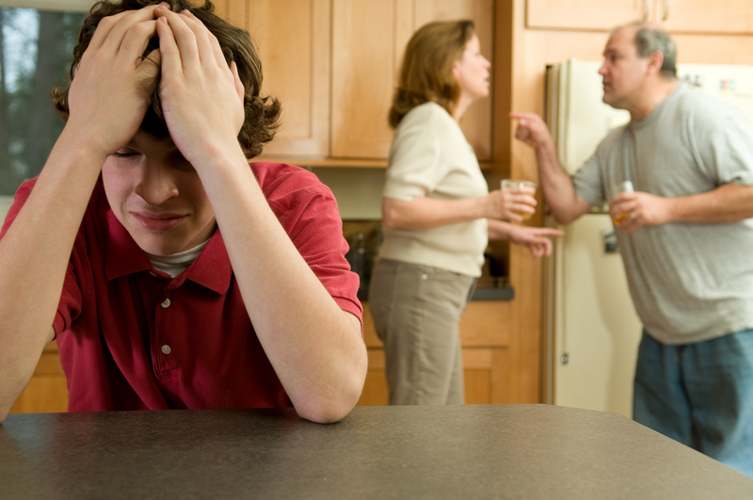
COUNSELLING
http://www.thegreenrooms.net/about-us
About Us – The Green Rooms

http://www.thegreenrooms/video
Videos – The Green Rooms

http://www.thegreenrooms/work-with-us
Work With Us – The Green Rooms
http://www. thegreenrooms.net/counselling-and-psychotherapy
Counselling & Psychotherapy – The Green Rooms
http://www. thegreenrooms.net/counselling-and-psychotherapy/individuals
Counselling and Psychotherapy for Individuals– The Green Rooms
http://www. thegreenrooms.net/counselling-and-psychotherapy/couples
Counselling and Psychotherapy for Couples – The Green Rooms

http://www. thegreenrooms.net/counselling-and-psychotherapy/children
Counselling and Psychotherapy for Children – The Green Rooms
http://www. thegreenrooms.net/counselling-and-psychotherapy/teenagers
Counselling and Psychotherapy for Teenagers – The Green Rooms
http://www. thegreenrooms.net/counselling-and-psychotherapy/families
Counselling and Psychotherapy for Families – The Green Rooms
http://www. thegreenrooms.net/counselling-and-psychotherapy/group-therapy
Group Counselling and Psychotherapy – The Green Rooms
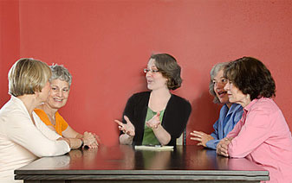
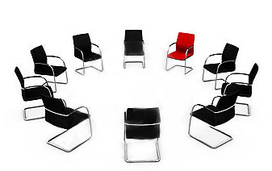
http://www. thegreenrooms.net/counselling-and-psychotherapy/supervision-for-professionals
Supervision for Professionals – The Green Rooms
http://www. thegreenrooms.net/counselling-and-psychotherapy/talking-therapies
Talking Therapies – The Green Rooms

http://www. thegreenrooms.net/counselling-and-psychotherapy/cognitive-behavioural-therapy-CBT
Cognitive Behavioural Therapy – The Green Rooms

http://www. thegreenrooms.net/counselling-and-psychotherapy/art-psychotherapy
Art Psychotherapy – The Green Rooms

http://www. thegreenrooms.net/counselling-and-psychotherapy/trauma-incident-reduction
Trauma Incident Reduction – The Green Rooms

http://www. thegreenrooms.net/counselling-and-psychotherapy/therapeutic-slimming
Therapeutic Slimming – The Green Rooms
http://www. thegreenrooms.net/counselling-and-psychotherapy/mindfulness
Mindfulness – The Green Rooms
http://www. thegreenrooms.net/counselling-and-psychotherapy/exposure-therapy
Exposure Psychotherapy – The Green Rooms
http://www.thegreenrooms.net/neuro-linguistic-programming-nlp
Neuro Linguistic Programming – The Green Rooms

http://www. thegreenrooms.net/neuro-linguistic-programming /urges-and-cravings
Neuro Linguistic Programming – Urges & Cravings – The Green Rooms

http://www. thegreenrooms.net/neuro-linguistic-programming/phobias
Neuro Linguistic Programming – Phobias – The Green Rooms
http://www. thegreenrooms.net/neuro-linguistic-programming/stress-reduction
Neuro Linguistic Programming – Stress Reduction – The Green Rooms
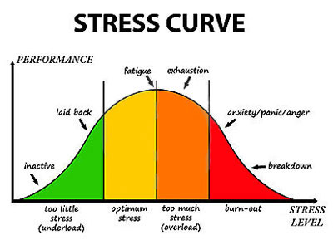
http://www. thegreenrooms.net/life-coaching
Life Coaching – The Green Rooms

http://www. thegreenrooms.net/life-coaching/work-life-balance
Life Coaching – Work Life Balance – The Green Rooms

http://www. thegreenrooms.net/life-coaching/relationships
Life Coaching – Relationships – The Green Rooms

http://www. thegreenrooms.net/life-coaching/confidence-building
Life Coaching – Confidence Building – The Green Rooms
http://www. thegreenrooms.net/life-coaching/business-partnership-building
Life Coaching – Business Partnership Building – The Green Rooms
http://www. thegreenrooms.net/employee-assistance
Employee Assistance Programme – The Green Rooms
http://www. thegreenrooms.net/training-and-facilitation
Training & Facilitation – The Green Rooms
http://www. thegreenrooms.net/appointments-and-fees
Appointments & Fees – The Green Rooms

http://www. thegreenrooms.net/appointments-and-fees/counselling-and-psychotherapy
Appointments & Fees – Counselling & Psychotherapy – The Green Rooms

http://www. thegreenrooms.net/appointments-and-fees/cognitive-behavioural-therapy-CBT
Appointments & Fees – Cognitive Behavioural Therapy – The Green Rooms

http://www. thegreenrooms.net/appointments-and-fees/group-therapy
Appointments & Fees – Group Therapy – The Green Rooms

http://www. thegreenrooms.net/appointments-and-fees/supervision-for-professionals
Appointments & Fees – Supervision for Professionals – The Green Rooms

http://www. thegreenrooms.net/appointments-and-fees/trauma-incident-reduction
Appointments & Fees – Trauma Incident Reduction – The Green Rooms

http://www. thegreenrooms.net/appointments-and-fees/therapeutic-slimming
Appointments & Fees – Therapeutic Slimming – The Green Rooms

http://www. thegreenrooms.net/appointments-and-fees/mindfulness
Appointments & Fees – Mindfulness – The Green Rooms

http://www. thegreenrooms.net/appointments-and-fees/neuro-linguistic-programming-NLP
Appointments & Fees – Neuro Linguistic Programming – The Green Rooms

http://www. thegreenrooms.net/appointments-and-fees/life-coaching
Appointments & Fees – Life Coaching – The Green Rooms

http://www. thegreenrooms.net/appointments-and-fees/training-and-facilitation
Appointments & Fees – Training & Facilitation – The Green Rooms

http://www. thegreenrooms/emergency-appointments
Appointments & Fees – Emergency Appointments – The Green Rooms
http://www. thegreenrooms/research-and-articles
Research & Articles – The Green Rooms
http://www. thegreenrooms.net/research-and-articles/wounded-healer
Wounded Healer - Research & Articles – The Green Rooms
http://www. thegreenrooms.net/research-and-articles/love
Love - Research & Articles – The Green Rooms
http://www. thegreenrooms.net/research-and-articles/food-drink-eating
Food, Drink & Eating - Research & Articles – The Green Rooms
http://www. thegreenrooms.net/research-and-articles/exercise-sport
Exercise & Sport - Research & Articles – The Green Rooms
http://www. thegreenrooms.net/research-and-articles/war-peace-politics-religion
War, Peace, Politics & Religion - Research & Articles – The Green Rooms
http://www. thegreenrooms.net/research-and-articles/modern-culture
Modern Culture - Research & Articles – The Green Rooms
http://www. thegreenrooms.net/research-and-articles/seasons
Seasons - Research & Articles – The Green Rooms
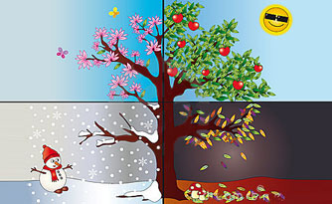
http://www. thegreenrooms.net/research-and-articles/easter
Easter - Research & Articles – The Green Rooms
http://www. thegreenrooms.net/research-and-articles/halloween-fear
Halloween & Fear - Research & Articles – The Green Rooms
http://www. thegreenrooms.net/research-and-articles/thanksgiving-giving-thanks
Thanksgiving & Giving Thanks - Research & Articles – The Green Rooms
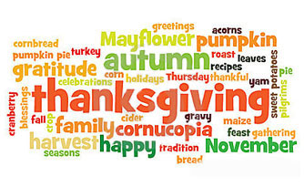
http://www. thegreenrooms.net/research-and-articles/festive-season
Festive Season - Research & Articles – The Green Rooms

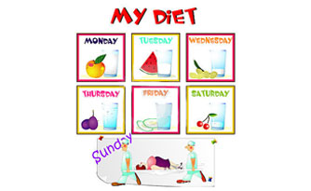
http://www. thegreenrooms.net/payment-options
Payment Options – The Green Rooms

http://www. thegreenrooms.net/locations-and-opening-hours
Locations & Opening Hours – The Green Rooms
http://www. thegreenrooms.net/locations-and-opening-hours/glasgow
Locations & Opening Hours - Glasgow – The Green Rooms

http://www. thegreenrooms.net/locations-and-opening-hours/newton-mearns
Locations & Opening Hours – Newton Mearns – The Green Rooms

http://www. thegreenrooms/contact_us
Contact Us – The Green Rooms

http://www. thegreenrooms/FAQ
FAQ – The Green Rooms

http://www. thegreenrooms/privacypolicy
Privacy Policy – Terms & Conditions – The Green Rooms

